INDEX

1.0 Introduction

1.1    Project Summary

1.2    Scope

1.3    Objective

1.4    Tools & Technology Used / Literature survey

2.0 System Requirements Study

                2.1    User Characteristics

                2.2    Hardware and Software Requirements

3.0    System Design

3.1   Project Flow

3.2   Data Dictionary Diagrams

3.3   Method Pseudo code/Sample code of main module

3.4   GUI Forms

4.0     Implementation Planning

4.1    Implementation Environment

4.2    Coding Standards

5.0   Limitations and Future Enhancement

6.0   Conclusion

**Introduction**

**1.1 Project Summary**

Price Comparison website is a vertical search engine that shoppers use to filter and compare products based on price, features, and other criteria. Price Comparison website also helps all the customers to buy products online at the lowest prices from the trusted ecommerce websites. Enter the product you wish to buy and compare the prices across wide range of E-commerce websites. You can also easily compare the features and price of mobile products in our website. You can also watch the images of mobiles from different sides. We also help you to redirect to the dedicated website of the product which is in progress mode. We can also help you to know the discounts and coupons. i.e having cash back offers from different banks, Big Billion Day etc…

**1.2 Scope**

This application will help the buyers to get the good products at the better prices. Users will be directed to different websites selling products from our websites.

**1.3 Objectives**

The main objective of our project is to get the cheapest price of the product you wish.

**(What it can do)**

The Website will help people to keep track of price of products on different websites and show them in ascending order in order to ease the online shopping for consumers.Right now, we are only dealing with the Mobiles & Accessories.

**(What it can’t do)**

This project compares the prices from the leading ecommerce websites only, all the ecommerce stores are not included yet. Prices of the products can still be decreased by applying coupon codes but it is not included in this project.

**1.4 Tools and Technology Used**

* Import.io

It is a tool which is used for Web scrapping and web crawling, we used this tool to extract data from ecommerce websites which is downloaded in .csv file formats and making it usable for our website.

* Macromedia Dreamviewer 8
* Kimono

Which is also used for extracting the data and keeping track to data.

* WAMP server

**2.0 System Requirements Study**

**2.1 USER CHARACTERISTICS**

Only **end user** has access to our website.

1. **End User**

End user is the final user that deals with the final result or Website. This is also known as user or final user that just uses the website for his/her purpose. User does not have authority to directly access database of the Website and change the features of this Website. It simply means the customer who is gonna buy the product.

* 1. **HARDWARE AND SOFTWARE REQUIREMENTS**

**FOR PC**

* **Hardware requirements:**
* 2.0GHz Processor
* 4GB RAM
* **Software requirements:**
* Computer with Operating system like Windows,Mac.
* Web Browser

**FOR MOBILE DEVICE**

* **Hardware Requirements:**
* 256 MB RAM
* 1 GHz Processor for better performance
* **Software requirements:**
* Android,IOS or Windows Operating System.
* Web Browser

**3.0 System Design**

**3.1 PROJECT FLOW**

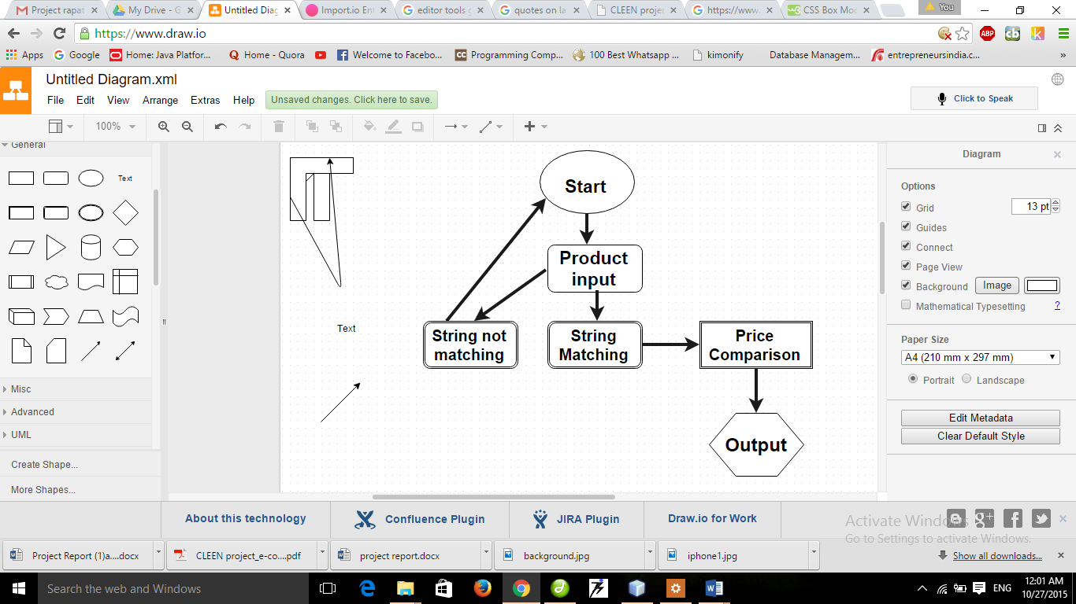

**User Flow diagram**

**3.2 DATA DICTIONARY DIAGRAMS**

**3.2.1 Data flow diagram**

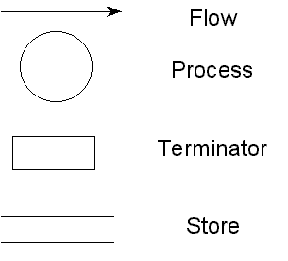

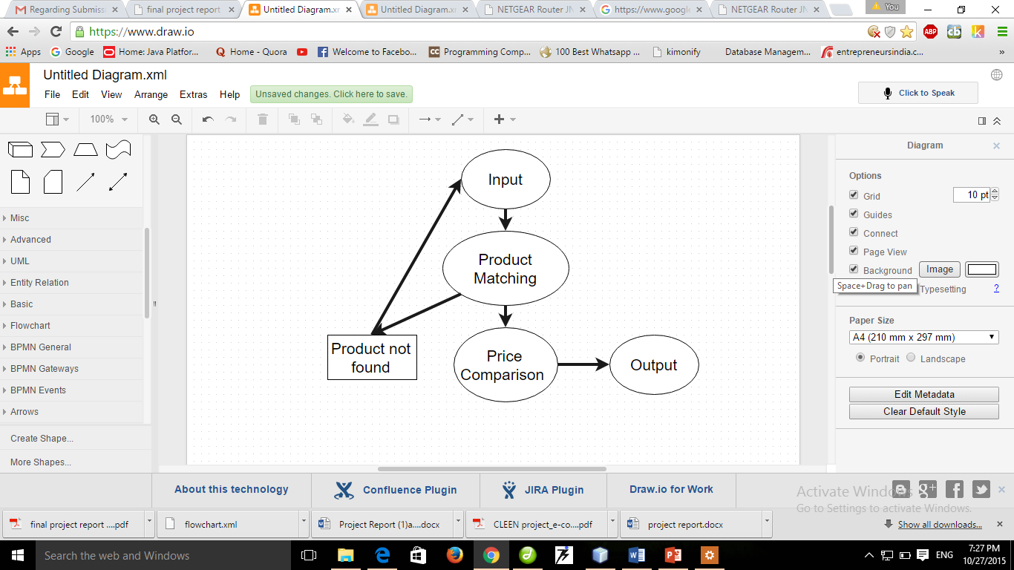

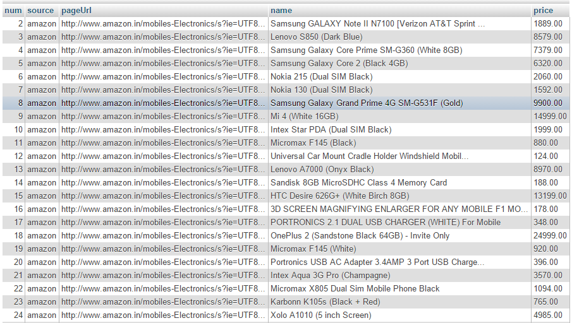

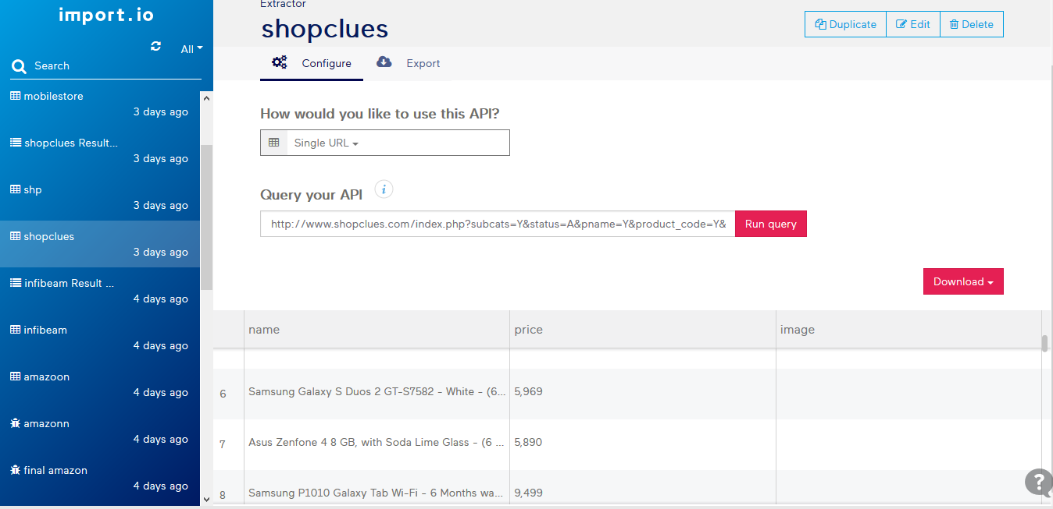

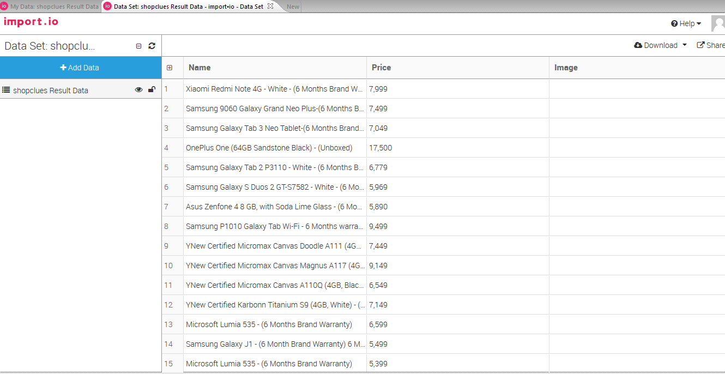

**3.3  Method Pseudo code/Sample code of main module.**

<?php

$min_length = 1;

if(strlen($query) >= $min_length)

{

$query = htmlspecialchars($query);

$query = mysqli_real_escape_string($con,$query);

echo "<table border='0' width='300' align='center' cellpadding='1' cellspacing='1'>";

echo "<tr align='center' bgcolor='#002C40' style='color:#FFF'>

<td height='35px' width='150px'>Name</td> <td>Price</td> <td>Source</td>

</tr>";

**$sql="SELECT * FROM data WHERE (`name` LIKE '%$query%')";**

$raw_results = mysqli_query($con,$sql);

if(mysqli_num_rows($raw_results) > 0)

{

while($results = mysqli_fetch_array($raw_results))

{

echo "<tr align='center' bgcolor='#0f7ea3'>

<td height='25px'>".$results['name']."</td> <td>".$results['price']."</td> <td>".$results['source']."</td>

</tr>" ;

}

}

else{

echo "<tr align='center' bgcolor='#6C0000'>

<td colspan='2' height='25px'>No results</td><tr>";

echo "</table>";

}

}

else{

echo "Minimum length is ".$min_length;

}}

?>

**3.4  GUI Forms(Web/Windows)**

<html xmlns="http://www.w3.org/1999/xhtml">

<head>

<meta http-equiv="Content-Type" content="text/html; charset=iso-8859-1" />

<title>Search</title>

<link href="style.css" rel="stylesheet" type="text/css" />

</head>

<body>

<form method="post" action="search.php" >

<table border="0" cellpadding="0" cellspacing="0">

<tr>

<td><input type="text" name="query" id="text" /><input type="submit" name="submit" id="search" value="Search" /></td>

</tr>

</table>

</form>

</body>

</html>



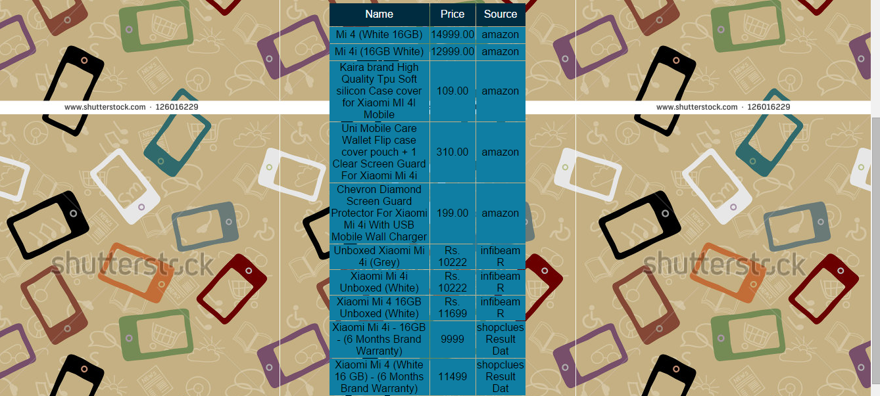

**4.0 Implementation Planning**

**4.1 IMPLEMENTATION ENVIRONMENT**

* **Single v/s multi-user environment:**

|  |  |
| --- | --- |
| Single environment | Multi-user environment |
| In a single-user environment, the workspace repository resides on the local machine, and can be accessed by the owner of the machine only. Limited facilities exist for sharing work with other users. | In a multiuser environment, the workspace repository resides on a database server, and can be accessed by any user with appropriate database privileges. |
| Single-user mode typically is reserved for special needs. | Most installations deploy Modernization Workbench in a multiuser environment. |

Our Project is Price Comparison Website it is of multi-user environment, anyperson at any corner of the world, having internet connection and fulfilling the software requirements can access our website and use it for buying products at better price.

So, our project is Multi user environment.

* **GUI v/s Non-GUI environment:**

|  |  |
| --- | --- |
| Non-GUI environment | GUI environment |
| Due to a higher degree of memorization and familiarity needed for operation and navigation, new users find operating a command line interface more difficult than a GUI. | Because a GUI is much more visually intuitive, new users almost always pick up this interface faster than a CLI. |
| Users have more control over both the file and operating systems in a command line interface. For example, users can copy a specific file from one location to another with a one-line command. | Although a GUI offers ample access to the file and operating systems, advanced tasks may still need to utilize the command line. |
| Command line users only need to utilize their keyboards to navigate the interface. Additionally, they often only need to execute a few lines to perform a task. | Using both a mouse and keyboard to navigate and control your operating or file system is going to be much slower than someone who is working in a command line. |

|  |  |
| --- | --- |
|  |  |

According to definitions above, we have used GUI environment in our project. As we have developed project that is visually used ie. User can interact with the application by interacting with graphical design. Here user does not have to interact with app using any command. So, implementation environment here is GUI based

**4.2 PROGRAM/MODULES SPECIFICATION**

There are three Modules in our Project

1.Website building.

2.Importing Data from websites and storing in Database.

3.Price Comparison Algorithm.

**4.3 CODING STANDARDS**

**HTML**

**Best Practices**

* **Use clear and precise names for IDs and classes**.
* **Choose names according to semantic meaning rather than presentation.**
* **Avoid using unnecessary classes and wrapper elements.**
* **Validate HTML.** A validator can often help a developer track down styling or scripting bugs. Valid HTML also increases the likelihood that a page will be displayed correctly in current and future browsers.

**CSS**

**Style Block**

Each style block should adhere to the following format:

selector { property: value; }

selector-2 {

  property: value;

  property: value;

}

.**Best Practices**

* **Use a global reset.** A global reset helps create more consistent presentation across browsers.
* **Use sprites for all rollover/active states.** CSS sprites prevent unwanted image flicker on rollover. CSS sprites also reduce the total number of HTTP requests.
* **Use as few browser-specific styles as possible.** If needed, browser-specific stylesheets or page classes (http://paulirish.com/2008/conditional-stylesheets-vs-css-hacks-answer-neither/) should be used instead of putting CSS hacks in the main stylesheet.
* **Validate CSS.**

**File Naming and Organization**

**Filenames**

Filenames should contain lowercase letters and words should be separated with a hyphen. The hyphen word separator (as opposed to an underscore or camelcase) is considered good practice for SEO reasons.

**CSS Stylesheets**

CSS stylesheets should be contained in a directory named 'css'. This directory will often contain a global reset stylesheet, named reset.css and a main stylesheet, appropriately named main.css. Any Internet Explorer-specific stylesheets should be named ie.css or ie7.css, etc. Other stylesheets may be added depending on the size and breadth of the website.

**PHP**

PHP is a server scripting language, and a powerful tool for making dynamic and interactive Web pages.

PHP is a widely-used, free, and efficient alternative to competitors such as Microsoft's ASP.

• PHP files can contain text, HTML, CSS, JavaScript, and PHP code

• PHP code are executed on the server, and the result is returned to the browser as plain HTML

• PHP files have extension ".php"

• PHP runs on various platforms (Windows, Linux, Unix, Mac OS X, etc.)

• PHP is compatible with almost all servers used today (Apache, IIS, etc.)

• PHP supports a wide range of databases.

**5.0 Limitations and Future Enhancements**

**LIMITATIONS:**

1. The user cannot cannot compare other features of products right now.
2. The user cannot get information about prices across all the ecommerce websites.
3. Database is manually updated so the actual prices sometimes may differ from the prices given in website.
4. It’s really static right now, so you cannot update the price as updated in e-commerce.

**FUTURE ENHANCEMENTS:**

1. In future, we will try to implement more better GUI .
2. We would try to implement a feature where products rating could also be seen along with trustworthy marks on the some of the products.
3. We will try to implement SMS and E-Mail system for user, just send the SMS or email and get the information about prices of products on different products.
4. Apply coupon codes implicitly and provide least price to customer.
5. Wallet integration for websites like Paytm.

**6.0 Conclusion**

These types of website are already there in Market .Websites like MySmartPrice.com, Junglee.com, Matchprix.com. Give the least price of the products and forward the client directly to the respective websites. This project taught us the use of the new age tools like import.io, kimono,the data extraction tools and How to work with them. It is good to learn the things which are in huge demand in real world. This project also polished our web designing skills and made us learn more about PHP. Our project can be future service also.